Adaptive Horizons: Navigating Museums in a Post-Pandemic World

Arthur Clay,
PERCEIVE Project, Lucerne School of Information Technology, HSLU
Giusy Grieco,
Classical Philology and Italian Studies Department (FICLIT), University of Bologna
Chiara Gemma Fedon,
PERCEIVE Project, Lucerne School of Information Technology
Dario Lanfranconi,
PERCEIVE Project, Lucerne School of Information Technology

Preamble

In 2020, museums, like many other public spaces and businesses, faced significant challenges due to the COVID-19 pandemic. When doors to museums were closed in response to the COVID-19 pandemic, several notable changes and developments occurred. In one of the first ICOM Community Resilience programs, we read: 'Try to focus on what you are doing best and seek alternative ways of doing it; try new things and revisit traditional ways of doing things.' One of the most demanding challenges indeed was going through a crisis in the absence of physical space and previous experiences coupled to those spaces.

In this article, we will therefore explore key moments in which the post-pandemic landscape is examined, ranging from the initial resilient responses to the latest innovations in dissemination. First, we will discuss the most effective strategies for addressing as-yet-unmet challenges; next, as we transition into the academic realm, we delve into the educational sector's context and the significance of knowledge design. Finally, in the last section, we dedicate ourselves to exploring potential actions within the market sphere, where we'll delve into the concept of growth marketing and innovative strategies (often referred to as 'hacking') to achieve rapid business expansion.

This article is intended to serve as an exploration of virtuous practices to adopt in the context of a new pandemic and, more broadly, in the post-COVID-19 era. It delves into the socio-technical value of museums, highlighting their contemporary, hybrid nature, which can adeptly navigate complexity through a holistic understanding of the problem-system.

Introduction

This article is divided into sections, each examining the evolving landscape of the post-pandemic museum from various perspectives. The first section investigates how museums globally have adapted strategies to address challenges yet to be met by suggesting inclusivity by seamlessly merging digital and physical experiences. The exploration encompasses lessons learned during the pandemic, revealing a visionary multisensorial approach that includes contemplating mobile satellite spaces for enhanced accessibility during crises.

Transitioning into academia, the second section illuminates observations of the pandemic's impact on cultural institutions through the perspectives of those involved in research and education. The section yields details on how museums are actively striving to balance physical and digital experiences, in an attempt to offer transformative solutions for improved visitor engagement, accessibility, and the overall museum experience. For example, the integration of Digital Twins into museum practices is being explored as a means of enhancing engagement. It offers innovative ways to create exhibition content and enables fresh interactions with visitors. Such an approach includes shedding light on museum practices that traditionally occur off-stage, within the museum's workspaces.

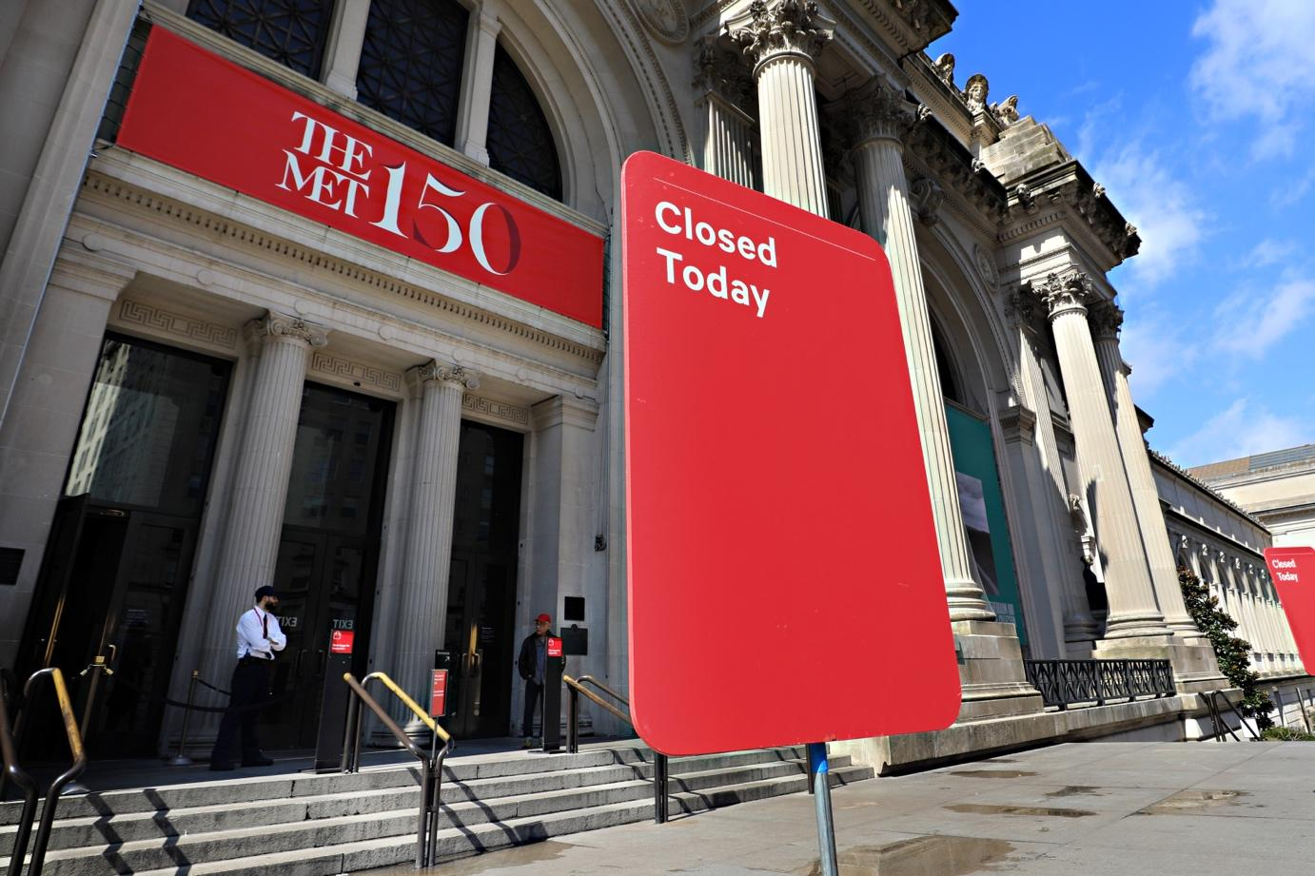
Fig. 1. During the COVID-19 pandemic, most museums were locked down with official announcements of closure, leaving no alternatives for audience engagement.

The third section, from a creative industry professional's perspective, delves into innovative technologies that led the way to possibilities and solutions catalyzed by the pandemic's transformative impact on museums. Focusing on virtual replicas and the potential of digital twins to replicate physical objects and processes, this narrative furthers the discussion and showcases how creative professionals leverage these technologies for immersive, engaging, and informative museum experiences. The final section delves into financial considerations for museums amidst challenges like reduced visitor numbers and the resulting economic strain. It explores potential financial solutions and resilience strategies, such as utilizing mobile satellite spaces and leveraging digital twins for revenue generation. Additionally, it scrutinizes the financial implications and benefits associated with marketing the rights to use digital replicas.

Taken as a whole, these narratives offer a nuanced exploration of how museums might be navigating the complexities of a post-pandemic reality, showcasing adaptive strategies across practical, academic, creative, and financial dimensions.

Fig. 2. displays an image that illustrates the process of acquiring the data to create a digital twin from its physical counterpart using structured light scanning.

I

Adapting Museums to the Post-Pandemic Era: Moving Beyond Recovery

The global COVID-19 pandemic has reshaped the strategies of museums worldwide, pushing them to adapt to varying regional challenges with varying levels of success. Initiatives that emerged during this period have now become integral parts of museums' ongoing offerings. As mentioned in the introduction, it's evident that the post-pandemic landscape has witnessed a significant shift toward a comprehensive and inclusive approach. This transition seamlessly merges digital and physical experiences to cater to a diverse audience, directly responding to the lessons learned during the pandemic, particularly in the realm of digital innovation, which experienced accelerated development at that time

With that, the way visitors perceive works of art led to a new way of experiencing the act of being in a museum. Every museum became a blended reality, entirely shifting onto social media and digital platforms. The true manifestation of what had been termed 'phygital' a few months earlier came to light. This, however, gave rise to some controversies: on one side, digital initiatives expanded the possibilities of reaching a new segment of the public; on the other, side effects like virtual fatigue and unequal access stemming from the digital divide phenomenon came to the forefront. This experience underscored the need for a more balanced cultural approach that effectively integrates both physical and digital offerings. Navigating the uncertainty began to require consideration of variables from the most disparate domains.

Reformulating (counter)narratives in the digital context meant, first of all, abandoning the impractical notion of returning to the top-down approach regarding the moral duty of historical conservation. It became clear that the significance reached far beyond this notion. Accessing digital twins (detailed 3D digital representations) of cultural heritage made us realize that the ghosts from the past were not only real but represented the first significant, transgenerational act of awareness

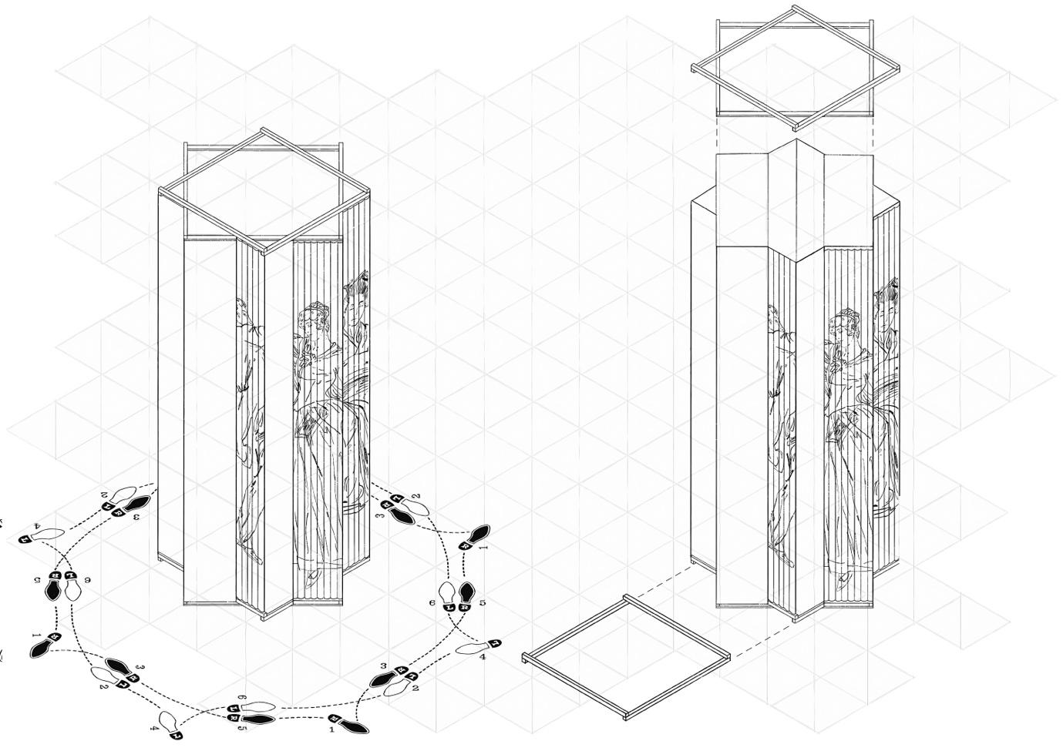

Fig 3. The Case Study Element “DANCESQUARED” of the Open Museum depicts the use of lenticular print animation to depict the fading of fading textile colors using physical interaction with the artifact under study. Image: Chiara Fedon with Dario Lanfranconi

Translating digital replicas into both physical and digital experiences is now considered a viable solution, offering innovative strategies for engaging the public when traditional access is limited. Laser scanning, 3D visualization, machine learning, and empowered rendering have the capability to create a significant impact in narrating the past and envisioning the future, all while maintaining interest in the present. The 'future of the past' not only lends credibility to the mission statement of museums but also contributes to their vision of making accessibility a priority within their spaces, making them adaptable for diverse purposes.

In the landscape of museums, where the integration of technology, adaptability, and inclusivity are key themes, the interaction of humans with computer systems and immersive environments is fundamentally a revolutionary information practice, created by people for people. In the “onlife” scenario, which refers to our lived experience of the ever-increasing pervasiveness of information and communication technologies, the continuous negotiation between heterogeneous (human and nonhuman) actors in the process of composing a common world nurtures the production of outcomes seen not as containers but as the result of the actors' interaction, i.e., an effect of the users' own contextualization in history.

Therefore, participative practices delve into a 'cosmos' of interactions, much like the old Kaiser panoramas attempted to reveal augmented realities. This approach is not about creating situations for debating the merits of a hybrid museum, but rather about how to open up the decision-making process to diverse actors, enabling the integration of additional values into the discussion. We will delve further into this matter in subsequent sections.

In this ever-evolving journey, museums are at the forefront of creating a harmonious future where the physical and digital realms seamlessly merge, ensuring that cultural experiences become accessible to all, transcending geographical and societal boundaries, and embracing the diverse needs of visitors in this post-pandemic era.

II Navigating the New Normal: A Scholarly Exploration of Museums in the Post-Pandemic Landscape

So, what about the academic and educational community, then? Inactivity was never an option. In this context, horizontal and decentralized approaches facilitated language and communication. As stated at the very beginning of this article, the primary concern was centered on the activation of virtuous practices, which would have had a significant impact in terms of training, resources, and cultural development. We can pinpoint a single term that embodies this mindset: 'growth culture.' The term 'growth' is commonly used in contexts like startup incubation and is typically employed when a company seeks to scale its business or at the outset of endeavors when everything is yet to be decided.

The imperative to balance physical and digital experiences has triggered a significant shift in the cultural landscape. Museums are exploring innovative avenues, with the creation of mobile satellite spaces being one such solution. In the wake of this transformative impact, academic institutes are prompted to align their post-pandemic research interests with the evolving landscape of museums.

Scholars explored museums' digital initiatives during the pandemic, encompassing virtual exhibitions, online engagement strategies, and the integration of emerging technologies. Analysis is underway to understand how the shift to digital experiences has influenced visitor engagement, satisfaction, and accessibility, with strategies identified to enhance the virtual museum experience. Additionally, research is focused on the feasibility, effectiveness, and impact of mobile satellite spaces, harmonizing physical and digital interactions, as these are seen as crucial in maintaining cultural engagement during crises. Scholars are also investigating the socio-economic impact of digital initiatives, addressing issues of accessibility, and ensuring inclusive access to cultural resources in the digital realm.

As is often the case in this type of scenario, significant contributions can be derived from systemic thinking and design. While our primary focus here is not on this topic, it is worth noting that the sociotechnical scenario offers a wide range of possibilities for the application of design thinking and feasibility studies. This is particularly relevant when the demand for evidence-based policy making necessitates collaboration between public and private organizations.

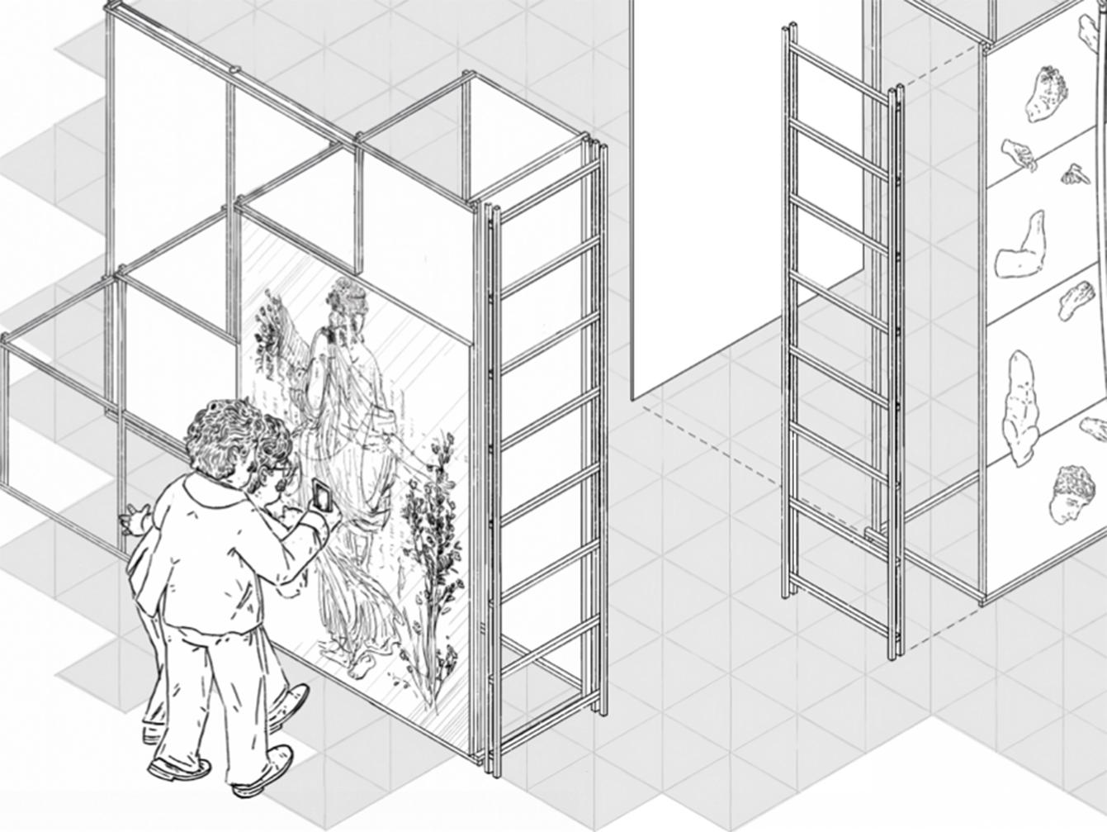
Fig.4. The Case Study Element “GREATWALL PRINT” of the Open Museum depicts the use of one-way mirror animation to shift between the digital restoration and of a fresco and it’s the condition of it at the present moment in time using a simple light from a mobile phone. Image: Chiara Fedon with Dario Lanfranconi

The illustrations of the Case Study Elements appearing in the sections of this text are intended to offer a valuable proposition that addresses the tension between various actors, the interplay of digital and physical interfaces, and the coexistence of tangible and digital twin experiences. In a single word: a hybrid experience. In this intertwining, academia feels the need to rely on more mixed-methods approaches in research, hybrid thinking, dropping the domain silos that goes back to the Kantian bi-dimensional rationality—a philosophical concept which explores the dual nature of human reasoning, considering both rational and non-rational factors. This represents a fair challenge when it comes to the curatorial practice of sharing culture and making every single voice heard, both from the tech and from the humanistic side.

The Digital Humanities response, while valuable, may not be sufficient on its own. We need both historical thinking and statistical approaches, alongside machine learning algorithms. The knowledge design for the future envisions an intertwining of various domains with a unique perspective: thinking like a historian, imagining like a designer, and conducting A/B tests. By relying on Academia, we adopt a disruptive approach to break down knowledge silos and a constructive one to design knowledge that addresses present needs.

We are approaching the third section of this article, where the role of culture as a means for social cohesion will be discussed. Before delving into that, it would be important to explore the concept of building secondary worlds for catastrophic contexts and solutions, which are a relevant factor when it comes to the authenticity of the onlife experience.

In a parallel vein, experts and conservators are actively crafting a defined methodology to guarantee 'authenticity' in both digital and physical reproductions of cultural artifacts. This involves transferring the authenticity factor from visually experiencing the artifact to the presentation of scientific tools and methods used in conservation and restoration processes. This scholarly exploration reflects the dynamic intersection of academia and museums, where research endeavors are crucial in shaping the future of cultural engagement in a post-pandemic world.

III Innovating Museums: A Creative Professional's Exploration of Post-Pandemic Possibilities

Delving into the creative industry, professionals have a unique lens on the transformative impact of the COVID-19 pandemic on museums, particularly the imperative to balance physical and digital experiences. This prompts a focus on specific areas of post-pandemic museum research that align with the creative industry's interests, emphasizing innovative solutions such as the use of virtual replicas and the media, as well as the strategies that accompany those solutions.

In response to this transformative impact, creative professionals explore the potential of digital twins, which are virtual replicas or representations of physical objects, systems, or processes. Digital Twins emerge as a powerful tool for effectively replicating objects using technology such as mobile phone AR and physical media like lenticular prints and multilayered transparencies. This approach not only showcases the object itself but also captures changes over time and the processes involved in extending an artifact's lifespan.

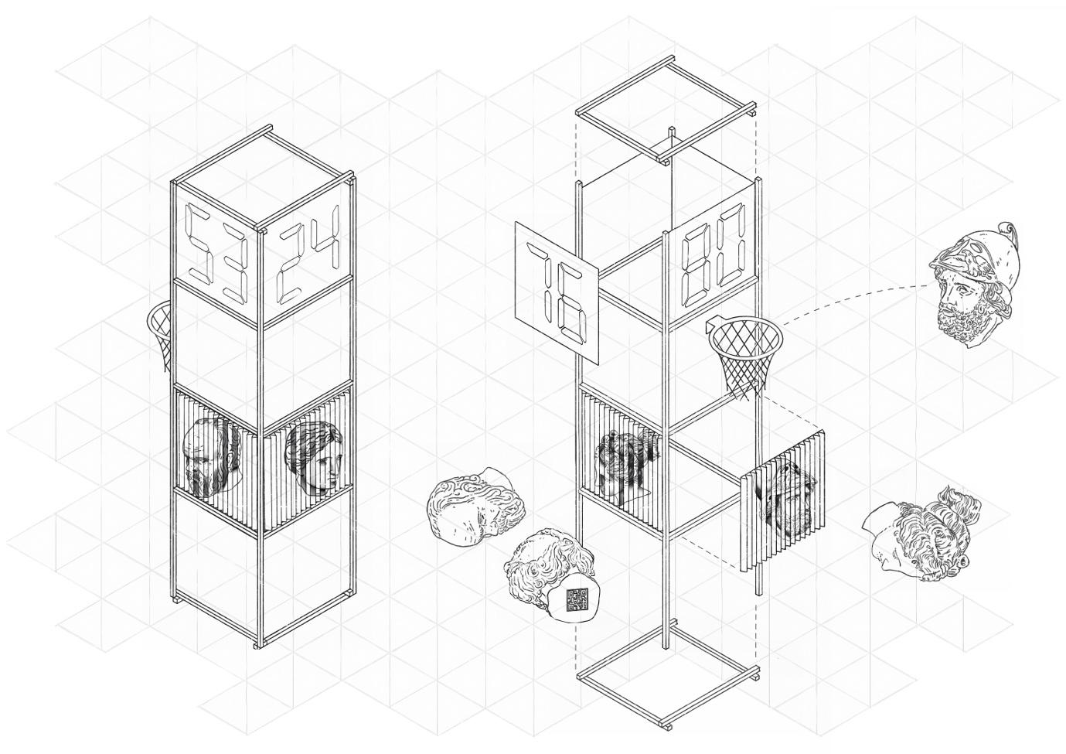

Fig.5. The use of physical replications of case study artifacts fabricated by using information available in digital twins of the artifacts. The foam rubber copies allow for the artifacts to be used in a contrasting scenario which in contrast to a museum context allows for a tactile experience using the replications in a playful way. Image: Chiara Fedon with Dario Lanfranconi

As a creative professional, engagement with digital twinning therefore becomes a dynamic exploration. This process involves manifesting digital twins in various materials and offering visitors immersive experiences to discover the exhibited object. The emphasis is on providing a comprehensive encounter that goes beyond mere visual observation, creating opportunities for a deeper understanding of the object and its evolution. Furthermore, the creative professional reflects on their contributions to such scenarios, considering the tools that have proven valuable and identifying tools that could enhance the creative process further if available. This analysis provides insights into refining and expanding the used toolkit for future endeavors in crafting innovative and engaging museum experiences.

Transformative narratives become magically real when different people from diverse backgrounds come together, navigating the challenges of contrasting misinformation and manipulation. The perennial challenge lies in harmonizing different languages. This is why knowledge design for social cohesion represents the initial step toward an innovative tech-led proposal for robust culture building. Embarking from the physical and material realm and transitioning seamlessly into the domain of the digital is a fascinating yet considerably complex opportunity. As Luciano Floridi states, 'We are not angels nor brutes (or robots)' because humanity is 'a beautiful glitch'. Museums are situated in the 'onlife,' where visitors are encouraged to actively participate in practices that help them explore both the commonalities that unite people and the areas of disagreement, engaging in what can be referred to as 'cohesion and controversy mapping' within cultural contexts."

In essence, the exploration by the creative industry professional reveals the potential for transformative and immersive narrative and narr(action)s, within and outside of museums, pointing toward a future where the boundaries between the physical and digital realms are seamlessly integrated to captivate and educate visitors.

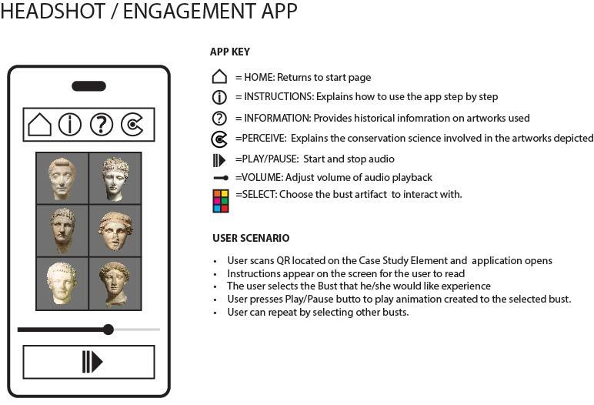

Fig.6. A mockup of an engagement application for the Case Study Element “HEADSHOT” which provides an example of how the concept of “Phygital” i.e physical plus digital) will work for blending digital experiences with physical ones.

Remixing the Zeitgeist

Creating transformative narratives involves different practices; speculative futures and strategic foresight, for example, are ways to envision potential post-pandemic scenarios in terms of probable, possible, and preferable futures. It is interesting how methods like social listening, netnography, and megatrend analysis reveal possible developments in terms of space and semantic capital usage, together with digital literacy and advocacy assessment.
Taking a look at the latest declarations after ResiliArt#5 Create 2030! by UNESCO, we cannot help but notice how the ICOM Resolutions back in 2019 (at the 25th General Assembly in Kyoto) had clear objectives in terms of the social dimension of the museum and its environmental footprint

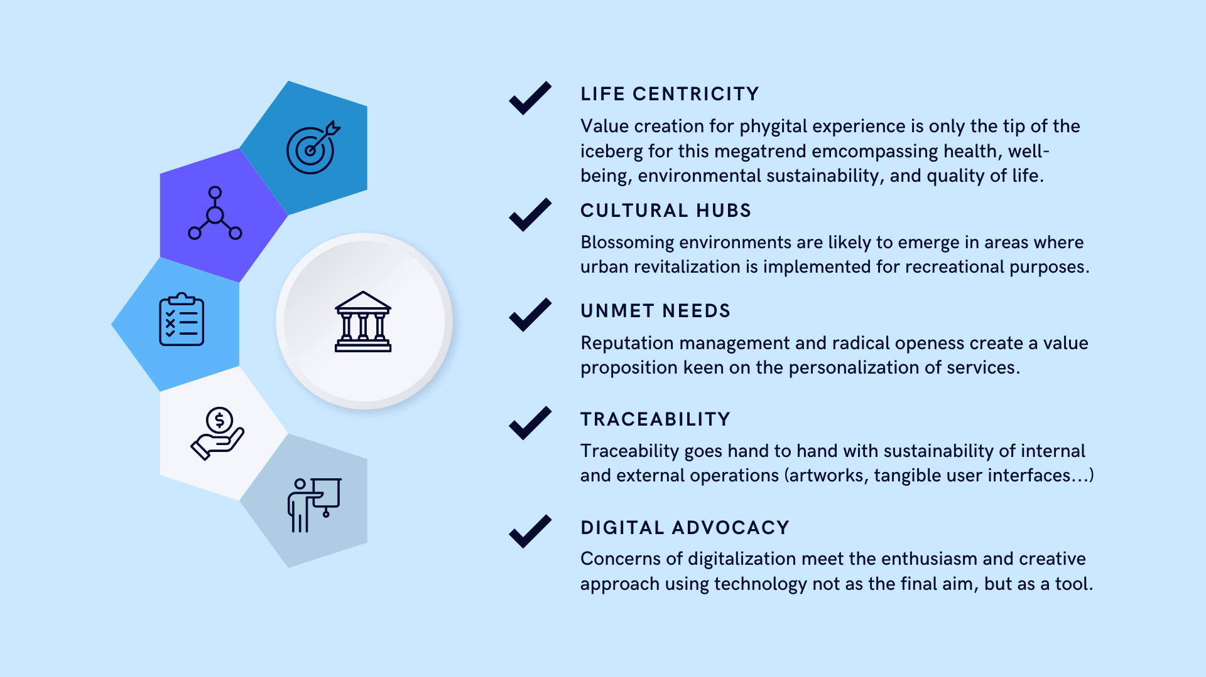

Fig. 7 illustrates the Post-Pandemic Museum Landscape, encompassing global trends and social listening. This diagram showcases the intricate dynamics within museum adaptation strategies, influenced by Agenda 2030, ICOM's 2019 Kyoto resolutions, and the Europeana Digital Transformation Report. Derived from cross-industry trends and netnography research, it presents a comprehensive approach to comprehending and shaping evolving cultural behaviors.

Here, we'll conduct a brief experiment to see how post-pandemic cultural objectives are entangled with major volatile, uncertain, complex, and ambiguous systems. In this context, let's unpack the wicked problem of Adapting to The New Normal, emphasizing virtuous practices as well as resilient praxes that merge art and technology. This endeavor is designed to create a qualitative vision of the future, one that embodies virtuous practices where we move beyond technology and embrace critical thinking. This qualitative perspective is termed 'virtuous practice,' symbolizing hybrid practices that serve as the vanguard of knowledge acquisition and communication across all facets of the quadruple bottom line as defined by the 'Sustainability Management in Museums' framework (SMM), consisting of profit, people, planet, and program elements and adapted by ICOM. These virtuous practices also represent a fundamental step for life during the 4th Revolution as they extend their reach into both the internal workings of the organization and its external interactions with the broader community and the world.

Addressing complexity-aware nudging for sensemaking praxes, as it is often impeded by dynamics reminiscent of dark patterns, brings transformative narratives to find their place, especially when various and diverse practices come into play. Speculative futures and strategic foresight, for example, offer methods to envision potential post-pandemic scenarios in terms of probable, possible, and preferable futures. Techniques like social listening, netnography, and megatrend analysis uncover potential advancements in spatial design and semantic capital usage, alongside digital literacy and policy assessment

An Informed, Virtuous Cycle of Practices

Taking a look at the latest declarations after ResiliArt#5 Create 2030! UNESCO, we cannot but notice how the ICOM Resolutions back in 2019 (3 th General Assembly in Tokyo) had clear objectives in terms of the social dimension of the museum and its environmental footprint.

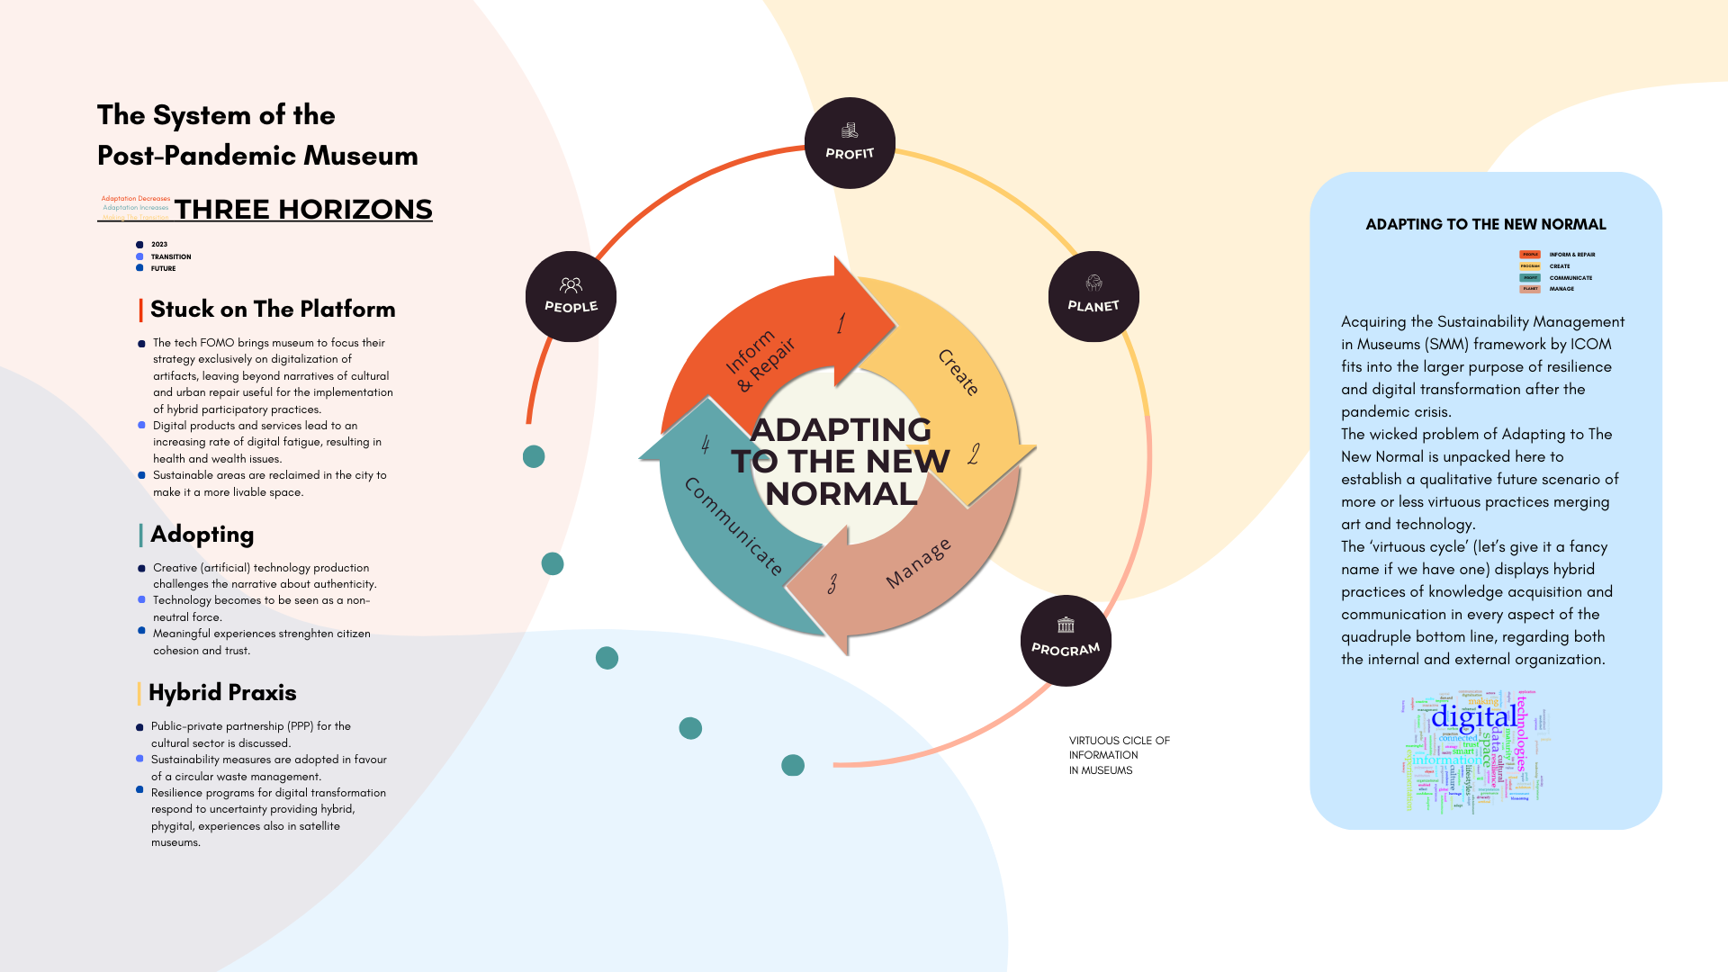
Fig.8. Within a resilience program's expansive scope, the museum's ecosystem emerges as a key player in addressing environmental and geopolitical challenges. Illustrated through the three horizons framework, three distinct approaches unfold, ushering in diverse futures, with one embracing adaptation through hybrid practices.

In this paragraph we’ll do a brief experiment to see how the post-pandemic cultural objectives are entangled to the major volatile, uncertain, complex, and ambiguous systems.
In this, we can try to unpack the wicked problem of Adapting to The New Normal, highlighting virtuous practices as well as resilient praxes of merging art and technology. This endeavor is designed to create a qualitative vision of the future, one that embodies virtuous practices where we go beyond technology and adopt critical thinking. This qualitative perspective is termed by us the 'virtuous practice,' which, as a term symbolizing hybrid practices, serves as the vanguard of knowledge acquisition and communication across all facets of the quadruple bottom line defined by the “Sustainability Management in Museums” framework (SMM)—consisting of profit, people, planet, and programme - adapted by ICOM.

These virtuous practices extend their reach into both the internal workings of the organization and its external interactions with the broader community and the world, and represent a fundamental step for life during the 4th Revolution.

The virtuous cycle of embracing the 'new normal,' situated within the broader context of the information society, manifests as a four-step praxis. Amidst the overarching trend of digital resilience and sensemaking production, significant emphasis is placed on curating and designing knowledge in complex times. The development of fresh languages and narratives proves valuable in both internal and external organizational contexts, transforming management into a shared responsibility for the ecosystem's vitality. Communication takes center stage, as both internal staff and audiences actively engage, evolving into advocates for the museum's vision. Juggling people, planet, profit, and programs becomes a dance of resilience and authenticity, carving spaces and exploring knowledge fringes for innovative sensemaking.

IV Investing in Museums: Financial Perspectives on Post-Pandemic Solutions

Shifting the focus to language entails a concurrent shift towards a consideration of the means and the desired outcomes. In this regard, the practice of growth hacking has emerged as a significant opportunity for museums, facilitating the expansion of their network and fostering collaboration with diverse professional domains, ultimately leading to the engagement of a more diverse audience.

The narrative delves into the feasibility of creating mobile satellite spaces and translating digital replicas into both physical and digital experiences. This approach is seen as a potential solution to several unresolved problems encountered by museums during the pandemic. These challenges include navigating the financial landscape in response to reduced visitor numbers, ensuring event continuity through robust strategies, fostering immersive and sensory experiences, addressing digital fatigue among visitors i.e. users, and sustaining collaboration through ongoing projects. A commitment to advancing accessibility and promoting inclusivity within the museum experience plays an integral role in strengthening our comprehensive and adaptive approach.

Here, the financial narrative then shifts to considerations about revenue generation through the creation of digital twins and exploring whether the museum has considered marketing the rights to use these digital replicas. The response to these questions provides a financial perspective on the potential benefits and challenges associated with leveraging digital twins for revenue generation. In the broader context, this exploration underscores the investor's interest in museums not just as cultural institutions but as dynamic entities with innovative solutions that align financial interests with the evolving needs of cultural consumers in a post-pandemic world.

In the aftermath of the COVID-19 pandemic, museums find themselves intricately connected to global trends, necessitating a nuanced approach that incorporates both divergent and convergent thinking. As illustrated in the above mapped diagram analyzing post-pandemic techniques employed by diverse museums, the adaptation process involves a divergent phase that reframes cultural systems and aligns them with post-pandemic objectives. This process draws insights from sources such as Agenda 2030, ICOM's resolutions post-34th general assembly, and the Sustainability Management in Museums framework, culminating in the Europeana Digital Transformation Report.

The study design integrates various methods and industry-agnostic trends, offering an initial step towards future strategic decision-making processes. The diagram, reflecting the phases of adapting to the "new normal" within the onlife scenario, also incorporates elements from Artificial Intelligence, Deepfakes, and a Future of Ectypes, drawing on Luciano Floridi's concept of "semantic capital." This underscores the multifaceted role of art not only as an actor in the post-pandemic scenario but also as a concept informing and repairing seamless creative tools towards research and development. As museums navigate this intricate landscape, they exemplify adaptive strategies aligned with broader shifts in global dynamics, epitomizing the delicate balance between tradition and innovation in the post-pandemic era.

Conclusion

In conclusion, the above narratives converge on the adaptive trajectories of museums in a post-pandemic reality. Addressing global challenges, museums navigate this new era by integrating digital and physical experiences, embracing inclusivity, and contemplating new avenues of activity. The academic exploration underscores a transformative shift, where scholars scrutinize the delicate balance between physical and digital realms, introducing Digital Twins and methodologies for authenticity. A creative professional's lens unveils immersive potentials through the hybrid use of digital twins, emphasizing the synthesis of physical and digital boundaries. Lastly, financial perspectives spotlight museums' resilience, emphasizing a balanced, inclusive approach for future viability. The surrogate use of mobile satellite spaces and the strategic use of digital twins emerge as solutions for sustained engagement and revenue generation. Together, these narratives offer a holistic understanding of museums' adaptive strategies across practical, academic, creative, and financial dimensions in the post-pandemic landscape.

See for more: Floridi L. (2016). The 4th revolution : how the infosphere is reshaping human reality ([Paperback edition] 1. impression). Oxford University Press.
Please refer to: Pescarin, S., Città, G., Gentile, M., Spotti, S. 2023c. Authenticity in VR and XR experiences: a conceptual framework for Digital Heritage. In EUROGRAPHICS Workshop on Graphics and Cultural Heritage. Lecce. See also: Carroll, G. R. (2015). Authenticity: attribution, value, and meaning. In Emerging trends in the social and behavioral sciences: An interdisciplinary, searchable, and linkable resource. Wiley. London.
Floridi, L. On Human Dignity as a Foundation for the Right to Privacy. Philos. Technol. 29, 307–312 (2016). https://doi.org/10.1007/s13347-016-0220-8
Please see for more: Wasielewski A. (2023) Computational Formalism: Art History and Machine Learning. The MIT Press
Please see for more: https://icom.museum/en/news/icom-voices-sustainability-management-museums/

